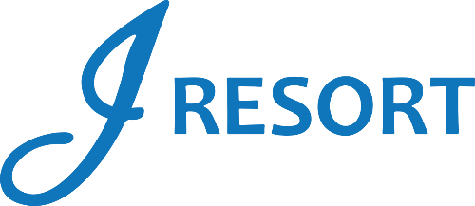
Winning Hands
Saturdays
April 2025
Rules & Regulations

- Promotion will take place every Saturday in April, from 3:00pm to 5:00pm at J Resort.
- Promotion open to every member of the J Rewards Club.

Participation Guidelines:
Starting April 4th, J Rewards club members who play live table games will receive a drawing ticket for this promotion.
Each time a member receives a “natural,” they will earn a punch on their drawing ticket for the upcoming Saturday drawing.
Once a ticket has 5 punches, the member must return it to a table games staff member, who will deposit it into the drawing drum.
- In Blackjack, a “Natural” is to reach a score of 21 with exactly two cards, an Ace and a ten-valued card (a 10, jack, queen, or king).
- In Craps, a “Natural” is a roll of two (2) dice with a score of 7 or 11 on the Come Out roll.

- Members must keep their drawing ticket until it has 5 punches.
- Once a ticket is completed and deposited into the drawing drum, members will receive a new drawing ticket.
- Members are responsible for keeping their tickets safe and not losing them.

Drawing Procedures:

- Drawings will be held at 3:00pm, 4:00pm, and 5:00pm on Saturday, April 5th, 12th, 19th, and 26th, with two winners selected at each drawing time.
- At 3:00pm, winners will receive $100 in Promotional Chips.
- At 4:00pm, winners will receive $250 in Promotional Chips.
- And at 5pm, winners will receive $500 in Promotional Chips.

- Winners must be present to claim their prize and will have 2 minutes to do so at the Table Games area.
- Participants can win once at each drawing time, with a maximum of 3 wins per Saturday.
- The drawing drum will be emptied each Saturday after the 5:00pm drawing.
- Promotional Chips can be exchanged to E-CASH.
- If Promotional Chips are exchanged, E-CASH will be available for 6 days.

- Members are responsible for all applicable taxes.
- Rules & Regulations are subject to change.
- Any JEI employees, agents, successors, or assignees are not allowed to participate in this promotion.
- No Odds On Promotions employees are allowed to participate in this promotion.
- One or more cameras will be filming the entire playing area at all times.
- Participation in this promotion grants J Resort permission to utilize any photos taken for Marketing purposes.
- Management reserves all rights to change, alter, or cancel this promotion at any time, with or without notice.

